Result section:

In our research we wanted to explore the affect of 3 different parameters on the image: window size, spatial sigma and tonal sigma.

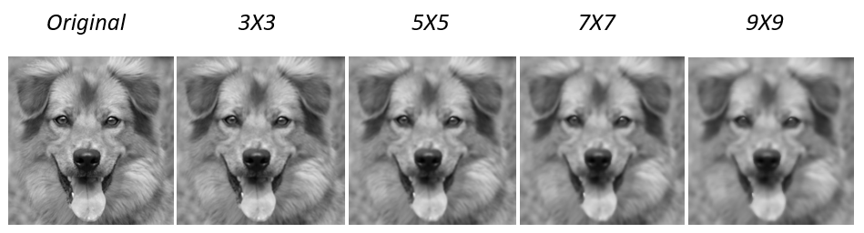Firstly, we observed the effect of the image window. We set the spatial sigma and tonal sigma to constant values (, and changed the window size. Here are the results:

In this experience we notice that as we increase the window size the image is more blur and the edges are less clear. On the other end, on a small window size, the changes are almost unseen. Therefore, we found are optimal window size for the rest of experience to be 5x5 or 7x7.

Our next faze was to examine the effect of the spatial sigma and tonal sigma. We set our window size to be 7x7 and changed the sigmas values as you can see in the image below:

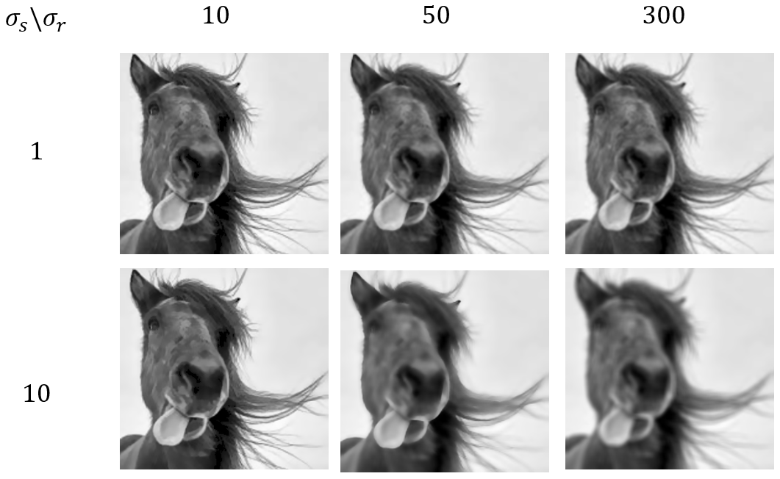

We can see that when is low, there is almost no affect of and all the images are remarkably similar to the original photo. That occurs since we almost do not take into account further pixels. As increases the affect of becomes much more significant.

In addition, we saw that if we take very high , the image returns very blur, that happens since we almost ignore the tonal differences hence the edges don’t remain.

In our last test we wanted to examine the effect on colourful images. From our previous experiences we decided to use larger spatial sigma and smaller tonal sigma while setting our window size to 5x5.

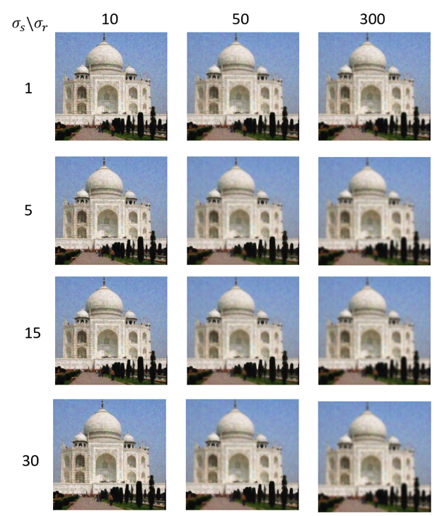

In addition, we examined the changes on a single pixel. We observed the values the pixel in location (100, 100) for each one of the pictures presented. The original pixel was: [ 89 126 133].

|  |  |  |  |
| --- | --- | --- | --- |
|  | 10 | 50 | 300 |
| 1 | (90.85, 125.46, 133.84) | (97.17, 129.16, 137.63) | (98.56, 129.97, 138.92) |
| 10 | (91.01, 125.94, 134.61) | (100.16, 131.6, 139.64) | (104.52, 134.37, 144.08) |
| 15 | (91, 125.95, 134.61) | (100.17, 131.61, 139.64) | (104.55, 134.4, 144.11) |
| 30 | (91, 125.94, 134.62) | (100.17, 131.61, 139.64) | (104.57, 134.41, 144.12) |